MySQL Database and Class Registratio

Selina Rodriguez

CST499: Capstone for Computer Software Technology

Instructor: Amr Elchouemi

January 25, 2021

Create your tables within the MySQL database.

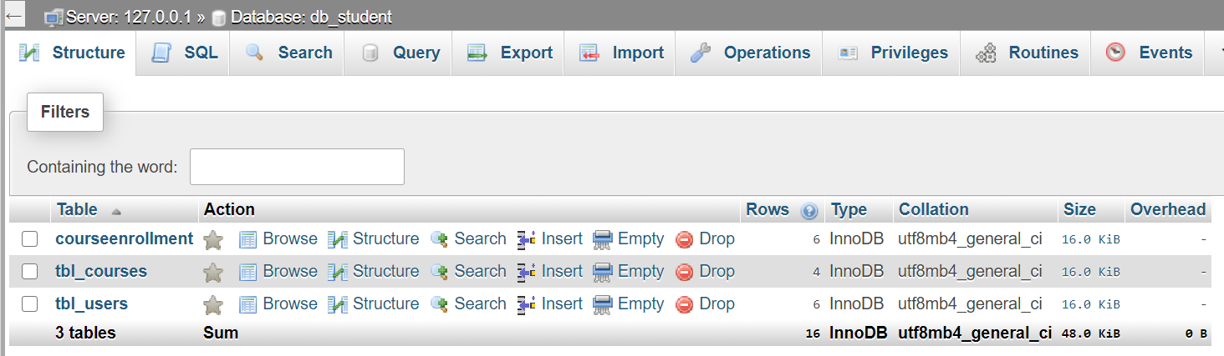

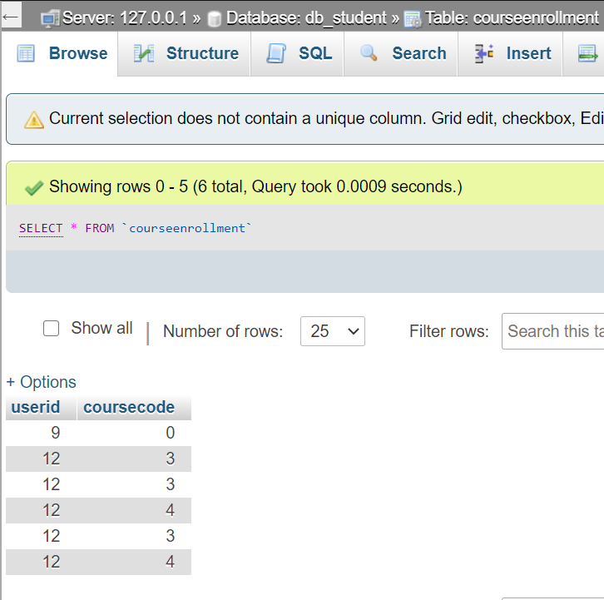

Connect your pages to the backend database.

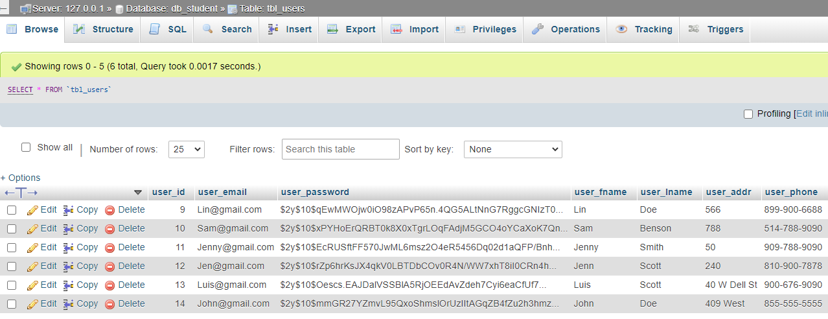

Create the register for classes.

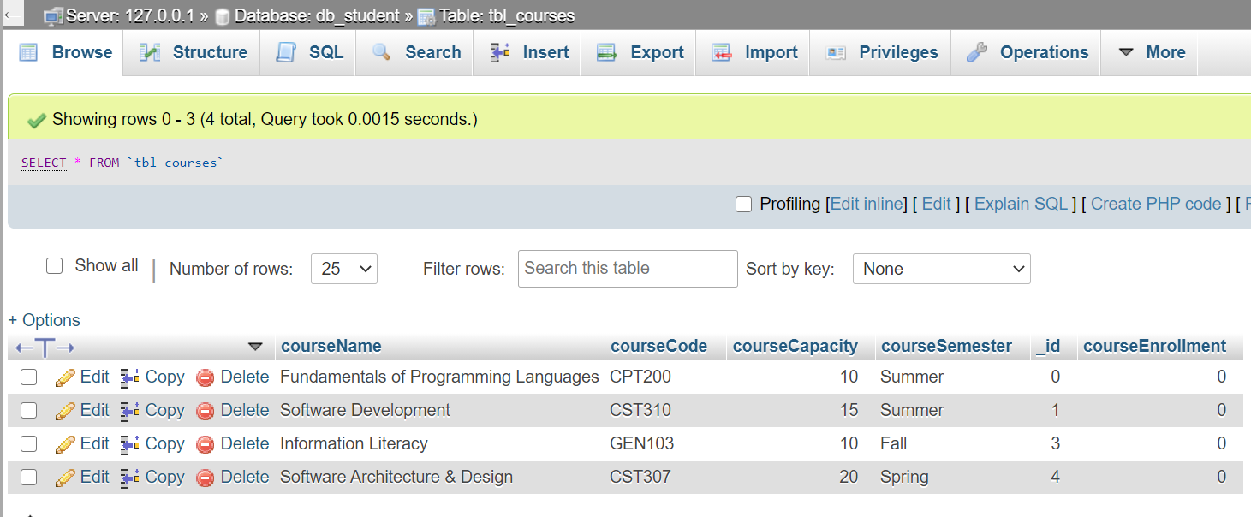

List classes you are registered for.

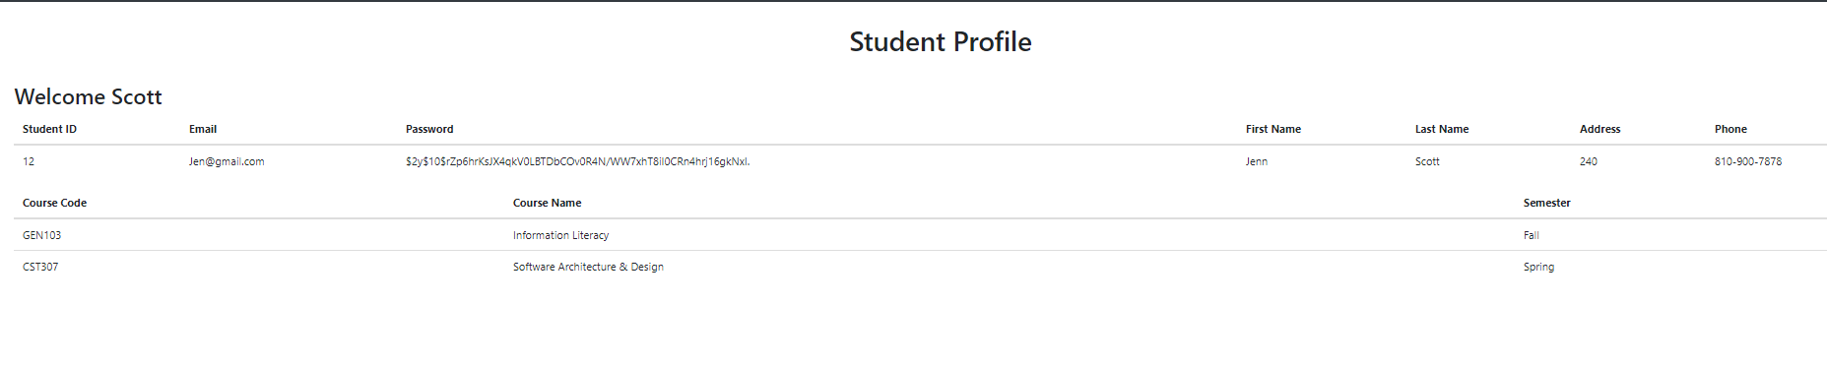

Add more courses to your semester.

